News Release
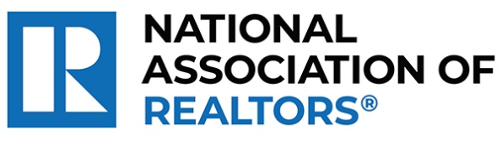 | MEDIA COMMUNICATIONS  For further information contact:  Spencer High, 202/383-1051  shigh@nar.realtor
Realtor® from Tenafly Wins National Award for Establishing Food Pantry Network Benefiting Thousands
WASHINGTON (October 5, 2023) – Realtor® Karen DeMarco with Coldwell Banker Residential Realty in Tenafly is one of five winners chosen as a recipient of the National Association of Realtors® Good Neighbor Awards.
DeMarco was inspired by her community’s support during her battle with breast cancer and decided to pay it forward. Within three years, she went from cooking meals in her kitchen to co-founding The Food Brigade, a food pantry network that has provided more than 1,700 tons of food to tens of thousands of people across three New Jersey counties.
“As we honor Karen, we are reminded of the broader purpose that unites us in the real estate profession,” said NAR President Tracy Kasper, a Realtor® from Nampa, Idaho, and broker-owner of Berkshire Hathaway HomeServices Silverhawk Realty. “Beyond sales and contracts, it’s the people, their stories and the shared dreams that matter. She is making a difference in her community and improving lives every single day, underlining the true spirit of community engagement.”
To view an electronic press kit for Karen DeMarco, including downloadable photos and videos, visit https://www.nar.realtor/good-neighbor-awards/karen-demarco-media-kit.
“Receiving the Good Neighbor Award brought into focus not just the significant impact of The Food Brigade in Northern New Jersey but also the ongoing needs of so many in our community,” said DeMarco. “While I love selling real estate, helping those who struggle to find housing is much more rewarding. As real estate agents, our prominent roles in the community places upon us a responsibility to give back and set a positive example for others.”
DeMarco and the other four Good Neighbor Award winners will receive a $10,000 grant for their charity and be featured in the fall 2023 issue of REALTOR® Magazine. NAR will formally present each with their award on November 15 during NAR NXT, the association’s annual conference that will take place in Anaheim this year.
NAR’s Good Neighbor Awards is supported by primary sponsor Realtor.com® as well as the Center for REALTOR® Development. In September, Realtor.com® invited the public to vote for their favorite of the 10 finalists. DeMarco ranked in the top three in the Web Choice Favorite voting and will receive a bonus $1,250 grant for her charity.
“This year’s Good Neighbor Award winners continue the tradition of raising the bar on what’s possible through giving back,” said Realtor.com® CMO Mickey Neuberger. “Their stories have moved us at Realtor.com® and we are honored to be long-time sponsors of the Good Neighbor Awards program.”
The National Association of Realtors® is America’s largest trade association, representing more than 1.5 million members involved in all aspects of the residential and commercial real estate industries. The term Realtor® is a registered collective membership mark that identifies a real estate professional who is a member of the National Association of Realtors® and subscribes to its strict Code of Ethics.
# # #
Information about NAR is available at nar.realtor. This and other news releases are posted in the newsroom at nar.realtor/newsroom.

