News Release
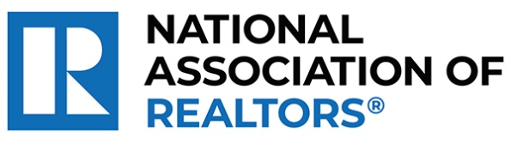 | MEDIA COMMUNICATIONS  For further information contact:  Mantill Williams, 202/383-1128  mwilliams@nar.realtor
National Association of REALTORS® Reminds Members and Consumers of Real Estate Practice Change Implementation on August 17, 2024
CHICAGO (August 1, 2024) – The National Association of Realtors® reminds members, real estate professionals, and consumers that on August 17, 2024 the practice changes following NAR’s Settlement Agreement that would resolve claims brought on behalf of home sellers related to broker commissions will be implemented across the country.
NAR recommends all MLSs implement practice changes by August 17. Realtor® MLSs (those owned exclusively by one or more Realtor® Associations) must implement the changes by this date to remain in compliance with NAR policy.
Under the settlement, the following practice changes will take effect:
- Offers of compensation will be prohibited on Multiple Listing Services (MLSs). Offers of compensation will continue to be an option consumers can pursue off-MLS through negotiation and consultation with real estate professionals. Offers of compensation help make homeownership and the benefits of professional representation more accessible to buyers—especially first-time homebuyers—increase homeownership opportunities for historically underserved groups, and benefit sellers by expanding the potential buyer pool and ensuring they receive the best offer possible for their property.
- Agents working with a buyer must enter into a written buyer agreement before touring a home. The practice changes do not require an agency agreement or dictate any type of relationship. NAR encourages all members to address form changes and prepare to educate real estate professionals and consumers about revised forms as soon as possible ahead of August 17. NAR policy does not dictate terms of buyer agreements, but NAR has created resources to assist with implementation of the settlement terms—such as tips on clarity and emphasizing consumer choice and a “Written Buyer Agreements 101” resource.

“NAR members are dedicated, intelligent, and highly adaptable experts in their fields—that’s why Realtors® are such an integral part of the homebuying and selling process,” said Kevin Sears, President of NAR. “These changes help to further empower consumers with clarity and choice when buying and selling a home. As the August 17 practice change implementation date approaches, I am confident in our members’ abilities to prepare for and embrace this evolution of our industry and help to guide consumers in the new landscape.”
Consumers can find additional information on what these changes mean for their homebuying and selling experiences in NAR’s buyers and sellers guides. For NAR members, the practice changes are outlined in detail here, and detailed information is available in NAR’s FAQ. Please visit facts.realtor for the latest updates on the settlement and practice changes.
About the National Association of Realtors®
The National Association of Realtors® is America's largest trade association, representing 1.5 million members involved in all aspects of the residential and commercial real estate industries. The term Realtor® is a registered collective membership mark that identifies a real estate professional who is a member of the National Association of Realtors® and subscribes to its strict Code of Ethics.
# # #
Information about NAR is available at nar.realtor. This and other news releases are posted in the newsroom at nar.realtor/newsroom.

