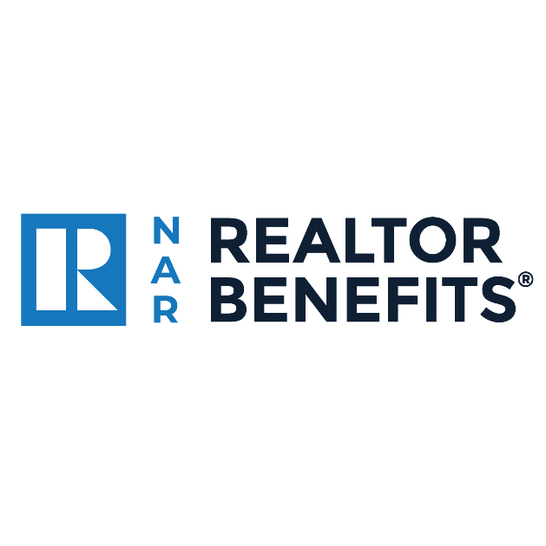

Leverage the Best of NAR REALTOR Benefits® for Your Success
NAR REALTOR Benefits® partners with select companies to create exclusive, customized offers that help you save on solutions that boost your business and best serve your clients.
Learn More

Featured Partners:
Technology:
Save 5-10% off All Dell Products
Dell is an American multinational computer technology company and is one of the largest technological corporations in the world. Dell offers NAR members exclusive discounts on a range of home and business class products.
Learn more | Get the offer

Enjoy up to 45% Off More on Lenovo’s Top-Selling Tech Products
Lenovo is a global technology leader, engineering innovative business class computing and software solutions for the home or home office.
Learn more | Get the offer

Streamline Transactions with Docusign’s Member-Only Pricing
DocuSign is the all-in-one solution for NAR members to streamline the transaction process by providing the tools to quickly access and fill out state and local association forms, obtain electronic signatures.
Learn more | Get the offer

RentRedi: America’s Trusted Property Management Software
Rentredi is the go-to platform for real estate professionals with property management. NAR members receive the first 6-month subscription of RentRedi for $1 and 50% of renewals.
Learn more | Get the offer

Business & Marketing:
Save Up to 20% on Printed Marketing Materials at FedEx
Trusted package delivery and business solutions partner FedEx offers a variety of special discounts on FedEx Office® printing and copy services, plus select FedEx shipping.
Learn more | Get the offer

Save Up to 26% on FedEx Shipments
Whether you need FedEx Express® U.S. shipping or FedEx Express international shipping, simply join the FedEx Advantage® program and start saving.
Learn more | Get the offer

Boost Your Industry Cred with Branded Goods from the
REALTOR Team Store®
REALTOR Team Store® is NAR's official supplier of REALTOR®-logo branded promotional products, offering a wide array of items, including lapel pins, bags, hats, shirts, decals, folders, jackets, and more.
Learn more | Get the offer

Power Up Your Rental Business with Rental Beast
Considered “the MLS of rentals,” Rental Beast offers an end-to-end leasing platform for lead generation and processing, plus a host of rental monetization tools all designed for real estate professionals.
Learn more | Get the offer

Education:
Build Up Your Buyer’s Side with an ABR® Designation Course
The Accredited Buyer's Representative (ABR®) designation course establishes a foundation of training, skills, and resources to help real estate professionals succeed as a buyer's representative.
Learn more | Get the offer

Punch Up Your Digital Profile with the e-PRO® Certification Course
The e-PRO® Certification course helps you expand your real estate technology and social media skills through two days of interactive coursework. Learn how to connect with consumers, manage your online reputation and generate leads.
Learn more | Get the offer

Separate Yourself from the Pack – Take the GREEN Designation Course
When you take NAR’s GREEN Designation course, you’ll learn how to increase your income by helping your clients make informed choices about the resource-efficiency and performance of their properties.
Learn more | Get the offer

Get Skilled at Serving Our Country’s Finest through the Military Relocation Professional (MRP) Course
Learn how to better serve the specific needs and timetables of relocating current and former military staff and their families by taking the Military Relocation Professional (MRP) Course.
Learn more | Get the offer

Get the Price Right – Save on the Pricing Strategy Advisor (PSA) Course
Pricing matters more than ever in this market – enhance your skills in determining property values, creating CMAs, working with appraisers, and guiding clients through their pricing anxieties with the PSA certification.
Learn more | Get the offer

Serve Seniors Better – Enroll in the SRES® Designation Course
Gain the knowledge and expertise you need to confidently counsel clients ages 50+ through major financial and lifestyle transitions, including relocating, refinancing or selling the family home with the SRES® Designation course.
Learn more | Get the offer

Insurance and Finance:
Credit Card Rewards Tailored for Your Real Estate Career with
NAR World Elite Business Mastercard®
NAR members have exclusive access to apply for the NAR World Elite Business Mastercard®, which offers up to 2.1% unlimited cash back on all purchases, 5% cash back on marketing expenses, and the opportunity to get a $500 sign-on bonus to help offset NAR membership dues. *
Learn more | Get the offer

Maximize Retirement Savings with IRAR Trust Company
IRAR helps you maximize your retirement savings by allowing investments in assets in which you have expertise—real estate. They make it easy for you to save, build retirement wealth, and grow your business.
Learn more | Get the offer

Save on Auto, Home, and Renters Insurance with Liberty Mutual
As NAR’s exclusive auto, home, and renter’s insurance provider, Liberty Mutual offers customized coverage, expert advice and a special auto insurance referral program that you can even extend to your clients.
Learn more | Get the offer

Minimize Your Risk – Leverage Victor’s E&O Insurance Coverage for Your Transactions
Victor Insurance Managers LLC is one of the largest and most experienced underwriting managers of specialty insurance programs in the world. Its first-class errors and omissions (E&O) insurance program puts you in touch with real estate underwriters who are skilled at evaluating your transaction risks.
Learn more | Get the offer
Make Sure You’re Covered – Get Exclusive Deals At REALTORS®
Insurance Place
NAR’s REALTORS® Insurance Place is an exclusive insurance shopping site created just for NAR members. It provides plans for you and your family, including health coverage options, group dental, group vision, and group life insurance, and more.
Learn more | Get the offer

E&O Insurance with Victor Insurance
Victor Insurance Managers LLC is one of the largest and most experienced underwriting managers of specialty insurance programs in the world. As an NAR member, you have access to exclusive cost savings on market-leading errors & omissions insurance.
Learn more | Get the offer

Travel & Automotive:
Save up to 35% Off on Your Car Rentals with Avis
Avis Rent-A-Car System LLC and its subsidiaries operate one of the world's best-known travel brands with 5,000+ locations in more than 165 countries.
Learn more | Get the offer

Save up to 35% Off on Your Next Car Rental with Budget
Renting great cars to value-minded customers since 1958, Budget is known for offering car rentals, products, and services for less.
Learn more | Get the offer

Get Exclusive Travel Perks and Car Rental Savings with Hertz
Hertz is a premier rental car company, offering travel perks and car rental savings at participating locations worldwide when enrolling in Hertz Gold Plus Rewards®.
Learn more | Get the offer

Save on Hotels, Rental Cars, Resorts, and More – Join the NAR Travel Club
Whether you're planning a business trip or a well-deserved vacation, NAR Travel Club saves you time and money on all your travel bookings.
Learn more | Get the offer

Save up to 25% Off on Premium Car Rentals
Don’t rent a car, rent THE car of your dreams with SIXT and save up to 25%. With more new cars and the premium brands you love, SIXT has your rental car needs covered in the United States and worldwide with more than 2,000 branches.
Learn more | Get the offer

Save on Auto Warranties with SnoopDrive
SnoopDrive offers NAR members top-rated auto warranties and protection products at unbeatable prices. A+ rated auto warranties and protection products—all online, with no calls or sales pressure.
Learn more | Get the offer

Exclusive Savings on Select New Mercedes-Benz Vehicles
NAR members are eligible for special incentives, which can save you anywhere from $500 to $9,500 on select new Mercedes-Benz vehicles.
Learn more | Get the offer

Home & Lifestyle:
Help Your Clients Declutter – Take Advantage of 1-800-GOT-JUNK? Exclusive Benefits
Whether you’re preparing a home to stage, cleaning a property before handing over the keys, or passing on the discount for your clients to use during their move, let 1-800-GOT-JUNK? do the heavy lifting for you.
Learn more | Get the offer

Save Time and Negotiate Repairs Faster with BOSSCAT Home Services
BOSSCAT provides prioritized online repair estimates and full-scale repair, renovation, and maintenance services for homeowners and NAR members.
Learn more | Get the offer

Earn Up to 30% Cash Back with Chirpyest
Create your own storefront and earn! Optimize and scale your real estate business with Chirpyest shopping tools. Curate, share, and earn when your client's shop
Learn more | Get the offer

Curbio: The Agent’s Home Improvement Partner
Curbio is the real estate agent’s go to contractor for getting homes market-ready with staging, painting, and more. Get homes market-ready – and sellers pay nothing until the house sells. NAR members get free access to Curbio’s ‘Build Your Own’ estimate app, including free repair estimates for home inspections upon PDF upload.
Learn more | Get the offer

Enjoy Exclusive Member-Only Pricing at the GE Appliances Store
Help boost your clients’ home value – and your value to them – by sharing top-of-the-line products at member-only pricing from the GE Appliances family of brands including Profile™, Cafe™, GE®, Monogram®, Haier, and Hotpoint®.
Learn more | Get the offer

