News Release
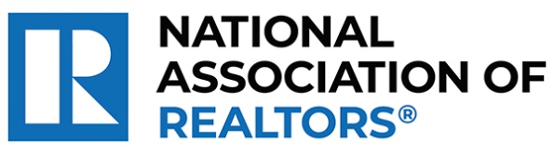 | MEDIA COMMUNICATIONS  For further information contact:  Spencer High, 202/383-1051  shigh@nar.realtor
Realtor® from Fernandina Beach Wins National Award for Creating Supportive Community for Autistic Teens and Young Adults
WASHINGTON (October 7, 2024) – Realtor® Stacy Horst with Keller Williams Atlantic Partners in Fernandina Beach is one of five winners chosen as a recipient of the National Association of Realtors® Good Neighbor Awards. Celebrating its 25th year, these distinguished awards spotlight Realtors® who are not only experts in their field but also champions of volunteerism.
Horst co-founded Erin’s Hope for Friends following the tragic loss of her 17-year-old daughter, Erin, who struggled with social connections and ultimately took her own life. In her memory, Horst and her husband established e’s Club, a supportive space for teens and young adults on the autism spectrum. The club fosters lasting relationships through joyful interactions and has positively impacted the lives of more than 1,500 individuals.
To view an electronic press kit for Stacy Horst, including downloadable photos and videos, visit https://www.nar.realtor/good-neighbor-awards/stacy-horst-media-kit.
“Stacy exemplifies the spirit of caring and the heartfelt commitment that defines the best of our profession,” said NAR President Kevin Sears, broker-associate of Sears Real Estate/Lamacchia Realty in Springfield, Massachusetts. “This dedication extends beyond traditional real estate boundaries. Stacy is forging significant, positive changes in her neighborhood and underscoring the vital role that agents who are Realtors® play in building stronger, more resilient communities.”
Horst will be awarded a $10,000 grant for their charity and be featured in the fall 2024 edition of REALTOR® Magazine. NAR will formally present each recipient with their official award on November 9 during NAR NXT, the association’s annual conference, hosted this year in Boston.
About the National Association of Realtors®
The National Association of Realtors® is America’s largest trade association, representing 1.5 million members involved in all aspects of the residential and commercial real estate industries. The term Realtor® is a registered collective membership mark that identifies a real estate professional who is a member of the National Association of Realtors® and subscribes to its strict Code of Ethics.
# # #

