News Release
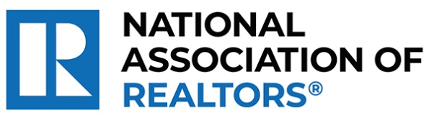 | MEDIA COMMUNICATIONS  For further information contact:  Spencer High, 202/383-1051  shigh@nar.realtor
Realtor® from Portland Wins National Award for Empowering LGBTQ+ Nonprofits with Vital Resources
WASHINGTON (October 7, 2024) – Realtor® Ed Gardner with Gardner Real Estate Group in Portland is one of five winners chosen as a recipient of the National Association of Realtors® Good Neighbor Awards. Celebrating its 25th year, these distinguished awards spotlight Realtors® who are not only experts in their field but also champions of volunteerism.
Gardner founded the Equality Community Center, which houses 18 LGBTQ-focused nonprofits under one roof with below-market rent. This arrangement fosters collaboration and increases operational efficiency among the organizations, reducing duplicated efforts. Additionally, he is spearheading the nonprofit’s latest project, the development of a 54-unit affordable housing complex for seniors.
To view an electronic press kit for Ed Gardner, including downloadable photos and videos, visit https://www.nar.realtor/good-neighbor-awards/ed-gardner-media-kit.
“Ed exemplifies the spirit of caring and the heartfelt commitment that defines the best of our profession,” said NAR President Kevin Sears, broker-associate of Sears Real Estate/Lamacchia Realty in Springfield, Massachusetts. “This dedication extends beyond traditional real estate boundaries. Ed is forging significant, positive changes in his neighborhood and underscoring the vital role that agents who are Realtors® play in building stronger, more resilient communities.”
Gardner will be awarded a $10,000 grant for their charity and be featured in the fall 2024 edition of REALTOR® Magazine. NAR will formally present each recipient with their official award on November 9 during NAR NXT, the association’s annual conference, hosted this year in Boston.
About the National Association of Realtors®
The National Association of Realtors® is America’s largest trade association, representing 1.5 million members involved in all aspects of the residential and commercial real estate industries. The term Realtor® is a registered collective membership mark that identifies a real estate professional who is a member of the National Association of Realtors® and subscribes to its strict Code of Ethics.
# # #

