News Release
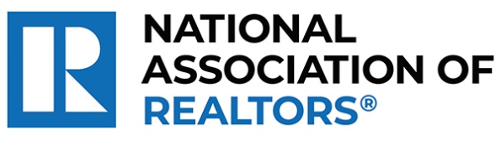 | MEDIA COMMUNICATIONS  For further information contact:  Spencer High, 202/383-1051  shigh@nar.realtor
Realtor® from Moab Wins National Award for Enhancing Healthcare in Rural Communities
WASHINGTON (October 7, 2024) – Realtor® Danette Johnson with Moab Realty in Moab is one of five winners chosen as a recipient of the National Association of Realtors® Good Neighbor Awards. Celebrating its 25th year, these distinguished awards spotlight Realtors® who are not only experts in their field but also champions of volunteerism.
Johnson was a founding member of the Moab Free Health Clinic, which was established in 2008 to serve uninsured and underinsured individuals in this rural and remote area. The clinic handles approximately 3,000 appointments annually, offering primary care, mental health services, vision screening and dental care. Using her real estate expertise, she helped the clinic secure larger facilities due to growing demand for its services.
To view an electronic press kit for Danette Johnson, including downloadable photos and videos, visit https://www.nar.realtor/good-neighbor-awards/danette-johnson-media-kit.
“Danette exemplifies the spirit of caring and the heartfelt commitment that defines the best of our profession,” said NAR President Kevin Sears, broker-associate of Sears Real Estate/Lamacchia Realty in Springfield, Massachusetts. “This dedication extends beyond traditional real estate boundaries. Danette is forging significant, positive changes in her neighborhood and underscoring the vital role that agents who are Realtors® play in building stronger, more resilient communities.”
Johnson will be awarded a $10,000 grant for their charity and be featured in the fall 2024 edition of REALTOR® Magazine. NAR will formally present each recipient with their official award on November 9 during NAR NXT, the association’s annual conference, hosted this year in Boston.
About the National Association of Realtors®
The National Association of Realtors® is America’s largest trade association, representing 1.5 million members involved in all aspects of the residential and commercial real estate industries. The term Realtor® is a registered collective membership mark that identifies a real estate professional who is a member of the National Association of Realtors® and subscribes to its strict Code of Ethics.
# # #

