News Release
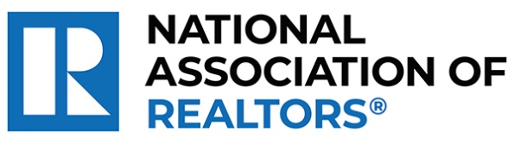 | MEDIA COMMUNICATIONS  For further information contact:  Spencer High, 202/383-1051  shigh@nar.realtor
Realtor® from Ellenwood Wins National Award for Advancing African American Youth Education and Leadership
WASHINGTON (October 7, 2024) – Realtor® Christopher Johnson with Imagine Associates LLC Realty in Ellenwood is one of five winners chosen as a recipient of the National Association of Realtors® Good Neighbor Awards. Celebrating its 25th year, these distinguished awards spotlight Realtors® who are not only experts in their field but also champions of volunteerism.
Johnson, a board member of 100 Black Men of DeKalb and holder of a doctorate in education, leverages his background as a teacher and principal to enhance educational and economic opportunities for African American youth. As a mentor, he teaches financial literacy and leadership skills, and organizes trips to broaden children’s horizons. He has contributed significantly to the growth of the organization at the local and national levels and has helped introduce financial literacy programs for teens to his local real estate board.
To view an electronic press kit for Christopher Johnson, including downloadable photos and videos, visit https://www.nar.realtor/good-neighbor-awards/christopher-johnson-media-kit.
“Christopher exemplifies the spirit of caring and the heartfelt commitment that defines the best of our profession,” said NAR President Kevin Sears, broker-associate of Sears Real Estate/Lamacchia Realty in Springfield, Massachusetts. “This dedication extends beyond traditional real estate boundaries. Christopher is forging significant, positive changes in his neighborhood and underscoring the vital role that agents who are Realtors® play in building stronger, more resilient communities.”
Johnson will be awarded a $10,000 grant for their charity and be featured in the fall 2024 edition of REALTOR® Magazine. NAR will formally present each recipient with their official award on November 9 during NAR NXT, the association’s annual conference, hosted this year in Boston.
About the National Association of Realtors®
The National Association of Realtors® is America’s largest trade association, representing 1.5 million members involved in all aspects of the residential and commercial real estate industries. The term Realtor® is a registered collective membership mark that identifies a real estate professional who is a member of the National Association of Realtors® and subscribes to its strict Code of Ethics.
# # #

