News Release
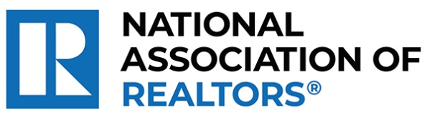 | MEDIA COMMUNICATIONS  For further information contact:  Spencer High, 202/383-1051  shigh@nar.realtor
Realtor® from Madison Wins National Award for Pioneering Local Nonprofit Funding Program
WASHINGTON (October 7, 2024) – Realtor® Charlie Wills with Charlie Wills Team–Real Estate Partners in Madison is one of five winners chosen as a recipient of the National Association of Realtors® Good Neighbor Awards. Celebrating its 25th year, these distinguished awards spotlight Realtors® who are not only experts in their field but also champions of volunteerism.
Wills, co-founder of 100 Men of Dane County, initiated a program where 100 community members make a significant impact by committing to donate $4,000 annually. Each quarter, they accept proposals from local nonprofit causes supporting children and select one to receive a $100,000 grant. To date, they have donated more than $2.3 million in grants, primarily benefiting small nonprofits.
To view an electronic press kit for Charlie Wills, including downloadable photos and videos, visit https://www.nar.realtor/good-neighbor-awards/charlie-wills-media-kit.
“Charlie exemplifies the spirit of caring and the heartfelt commitment that defines the best of our profession,” said NAR President Kevin Sears, broker-associate of Sears Real Estate/Lamacchia Realty in Springfield, Massachusetts. “This dedication extends beyond traditional real estate boundaries. Charlie is forging significant, positive changes in his neighborhood and underscoring the vital role that agents who are Realtors® play in building stronger, more resilient communities.”
Wills will be awarded a $10,000 grant for their charity and be featured in the fall 2024 edition of REALTOR® Magazine. NAR will formally present each recipient with their official award on November 9 during NAR NXT, the association’s annual conference, hosted this year in Boston.
About the National Association of Realtors®
The National Association of Realtors® is America’s largest trade association, representing 1.5 million members involved in all aspects of the residential and commercial real estate industries. The term Realtor® is a registered collective membership mark that identifies a real estate professional who is a member of the National Association of Realtors® and subscribes to its strict Code of Ethics.
# # #

